Extra References

Review article, switching field 2 or even number per solar rotation

<https://arxiv.org/pdf/1008.0771.pdf>

Fluctuations in Field

<https://ac.els-cdn.com/B9780444518811500022/3-s2.0-B9780444518811500022-main.pdf?_tid=23ef9fe4-4340-47ef-9533-1c0416f80adc&acdnat=1521372141_5fddbf43f25d36d1c27a1459dc22f7be>

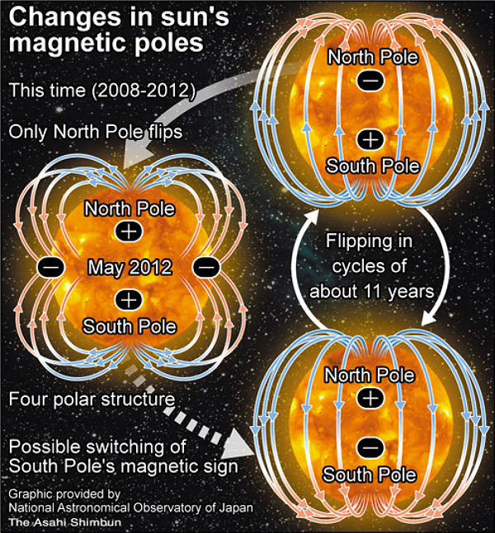

Quadrupole behaviour

‘In the Autumn of 2012 the magnetic field of the south pole finally showed signs of weakening. This began the normal trend towards a flip, and foiled any chance of a long-term asymmetry. Therefore the quadrupole configuration was temporary, and the Sun is now (Feb. 2013) reverting to its normal dipole configuration, as shown in the bottom right of the diagram above.’

<http://home.earthlink.net/~horizon18/solar_quad.htm>